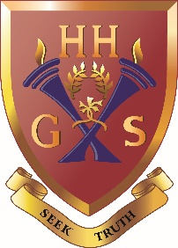
An independent co-educational school accredited by the Independent Schools Council
Hulme Hall Grammar School
Caring Nurturing Achieving

December 2020

Dear Parents/Carers

Non Uniform Day
Thursday 17th December 2020

School would like to have a fundraising push in support of this year’s nominated charity, The Wellspring. During the academic year 2019/20 the School Council voted unanimously to have The Wellspring as our beneficiary. The charity supports the homeless by providing hot meals and showers; clothing; health services; housing advice; professional support and a friendly welcome.

We will be having a non-uniform day on Thursday 17th December. Pupils may wear their own clothes and are asked to make a minimum donation of £2 to the school charity via their Form Tutors.

May I remind pupils to wear sensible clothes and footwear and to re-iterate school rules regarding jewellery and hair for health and safety reasons. Pupils who have PE on Thursday remember to wear / bring a pair of trainers. There will be no changes to the timetable, so pupils should bring in their usual books and equipment.

Our Hulme Hall family has always supported opportunities to raise money for charity and pupils and parents continue to demonstrate their kindness by putting others first.

Thank you for your continued support.

Yours faithfully
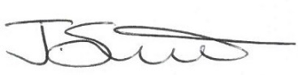

Jackie Smith
Assistant Headteacher
S21

