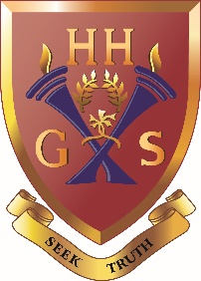
An independent co-educational school accredited by the Independent Schools Council
Hulme Hall Grammar School
Caring Nurturing Achieving

December 2020

Dear Parent/Carer

Christmas Lunch - Wednesday 9th December 2020

As in previous years, the Christmas Lunch on Wednesday 9th December is being offered to all pupils.

Christmas Menu

Traditional Roast Turkey served with
Pigs in Blankets, Stuffing and Cranberry Sauce

Roast Potatoes, Buttered
Carrots, Shredded Sprouts with Bacon and Roast Parsnips

Butternut Squash and Gruyere Pithivier
served with Vegetarian Gravy

Traditional Christmas Pudding
served with Custard

Mince Pies / Yule Christmas Log / Satsumas

If your child does not usually have a school meal and would like a Christmas lunch, please complete the reply slip overleaf no later than Monday 7th December 2020. The cost of this meal will be £4.00 (cheques made payable to ‘Hulme Hall Educational Trust’). If your child already pays for a school lunch or is having their own packed lunch, there is no need to reply.

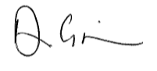
Yours faithfully

Dean Grierson
Headmaster
S20

Reply Slip
Christmas Lunch
Wednesday 9th December 2020

Please return to Form Tutor no later than Monday 7th December 2020

My child would like a Christmas lunch and I have enclosed £4.00

Name of Pupil: _______________________________________ Form: ____________________

Signed: ________________________________________________ Date: _____________________

