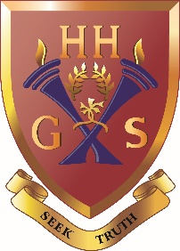
An independent co-educational school accredited by the Independent Schools Council
Hulme Hall Grammar School
Caring Nurturing Achieving

December 2020

Dear Parent/Carer

HOUSE TALENT CONTEST - HULME HALL’S GOT TALENT!

As you may be aware, every Christmas I host a House Talent Contest with each participant gaining 20 points for their House. On top of this there are other points awarded:

150 House points for First place
100 House points for Second place
50 House points for Third place

Owing to COVID restrictions, this year’s House Talent Contest will be screened in form rooms on Friday
18th December, the last day of term.

In order to facilitate this, I need your help. If your child has a particular talent as a dancer, singer, magician, musician, comedian, actor, athlete or any other talent they may have, then please could you video them and send the clips to me to my email address s.ahsan@hulmehallschool.org. The clips will then be put together to create the Talent Contest. Clips should be no longer than 3 minutes long.

All videos must be submitted by Wednesday 16th December, but don’t delay as we will need plenty of time to create what I’m hoping will be a fantastic end to the term!

I look forward to hearing from you and watching your child’s talent.

Yours faithfully
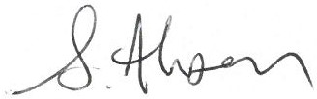

Ms Ahsan
Head of Drama
S18

