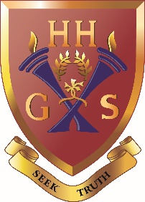
An independent co-educational school accredited by the Independent Schools Council
Hulme Hall Grammar School
Caring Nurturing Achieving

23rd November 2020

Dear Parent / Carer
Further to Mr Grierson’s letter sent last Friday, due to the current Covid-19 restrictions we have decided to make our Year 11 Parents’ Evening on Thursday 3rd December 2020 an online event. It will be hosted by a company called School Cloud.

Please download the attached help sheet to assist you with logging on to the portal.

Once logged on, you will be able to book appointment times to meet your son / daughter’s teachers. The evening will run from 5.30pm to 8.00pm.

You should book an appointment with each teacher that teaches your child, other than for Science, where I would ask that you follow the procedure outlined below. Each appointment will last for 8 minutes.

Science: If your son/ daughter has opted for Combined Science, please only book an appointment with one of the science teachers. They will have all the information regarding progress across all three sciences. The list of who you need to make your appointment with is below.
Mr Ryan | Mrs Basu | Mrs Pendleton
Joshua | Qazi | Sabrina
Thomas | Archie | Jake
Ben E | Steven | Emma
George | Maximus | Imogen
Millie | Jack | Lexie
Sophia | Benjamin H | Jacob
Harvey

If your son / daughter has opted for Separate Sciences, you will be required to make a separate appointment with all three teachers.
Art: If your child has opted for two different Art subjects such as Art and Design and Photography, or 3D Design and Photography, you will only be required to book one appointment with Mrs Oakes.
The booking system will go live from Tuesday 24/11/20 at 9a.m. Please ensure that you have booked all your appointments by Wednesday 2/12/20 at 4p.m.

If you have any problems logging on to School Cloud and making appointments, please do not hesitate to get in touch with me, either by telephone or email at p.bradford@hulmehallschool.org
After Parents’ Evening
If you have any general concerns or questions after Parents’ Evening, you are welcome to book a separate appointment with the relevant staff member:
Mr Grierson – Headmaster - secretary@hulmehallschool.org
Mr Bradford – Assistant Headteacher (Curriculum) - p.bradford@hulmehallschool.org
Mrs Smith – Assistant Headteacher (Pupil Progress / Careers Advice) - j.smith@hulmehallschool.org
Mr Lamerton – Head of Key Stage 4 and Examinations Officer - r.lamerton@hulmehallschool.org
Mrs Conway – Safeguarding (DDSL) - k.conway@hulmehallschool.org
Lisa Spragg – SENCo – l.spragg@hulmehallschool.org

To make the appointment, please e-mail the member of staff you wish to speak to. We will be happy to contact you and arrange either a face-to-face meeting or an online appointment via Microsoft Teams or agree a mutually convenient time to speak over the phone.

Yours faithfully
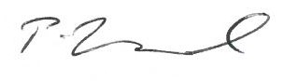
Mr Philip Bradford
Assistant Headteacher (Curriculum) S17

