An independent co-educational school accredited by the Independent Schools Council
Hulme Hall Grammar School
Caring Nurturing Achieving

November 2020

Dear Parent/Carer

I would like to inform you that I have set up a revision session for all Year 11 pupils taking GCSE History.
I would strongly advise that pupils attend.

Sessions will commence on:

Friday 25th November from 3.30 – 4.15pm

Pupils will need to bring their Weimar and Nazi Germany textbook and revision guides. These revision sessions are very important to the pupils and I look forward to seeing them.

Thank you for your support.

Yours faithfully
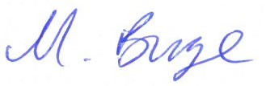

Mrs M Burge
Teacher of History

S16

