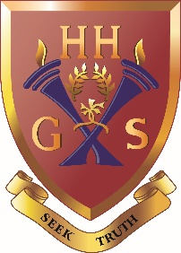
An independent co-educational school accredited by the Independent Schools Council
Hulme Hall Grammar School
Caring Nurturing Achieving
November 2020

Dear Parent/Carer

We have recently had a few enquiries regarding LAMDA provision at our school and, as such, would like to gauge how much interest there would be if we were to offer this programme.

The London Academy of Music & Dramatic Art examinations (LAMDA) has been offering practical communication and performance assessments over the last 130 years, providing each learner with the skills and confidence to succeed in life by developing attributes such as self-confidence and the ability to communicate clearly and present ideas. Having qualifications in LAMDA has helped hundreds of thousands of candidates of all ages and abilities to develop lifelong skills. LAMDA is recognised both by OFQUAL and LAMDA Grades 6 to 8 count towards UCAS admissions points.

Here is a list of LAMDA qualifications offered:

Entry Level
Level 1 Grades 1-3
Level 2 Grades 4-5
Level 3 Grades 6-8 (Count towards UCAS points)

These qualifications focus on acting, performance techniques and musical theatre skills. Also, speaking in verse and prose, as well as developing a strong speaking voice, public speaking and memorising skills. In addition to this, improving conversational skills, understanding of non-verbal communication by exploring body language and facial expression.

Lessons would be during the school day, taught in the same way as peripatetic music lessons.

If you are interested in this programme please contact d.cooke@hulmehallschool.org

We look forward to hearing from you.

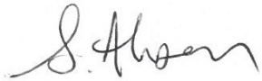
Yours faithfully

Ms S Ahsan
Head of Drama S15

